SVCR GOVERNMENT DEGREE COLLEGE PALAMANER

A STUDY PROJECT ON
ELECTRICAL SUBSTATION

CREATED BY GUIDED BY
BUNEKUNTA BABU SRI. M. SURYASEKAR REDDY
II BSC (MPCS) (B.ED , M.SC, P.HD)
ADMIN NO: 8862 DEPARTMENT OF PHYSICS
2021-2022

INDEX
S.NO | TITLE | PAGE NUMBER
1. | INTRODUCTION OF ELECTRICAL SUBSTATION | 2
2. | TYPES OF SUBSTATIONS | 3
3. | ELEMENTS OF SUBSTATION | 4
4. | 33/11KV SUBSTATION | 4
5. | THREE PHASE ELECTIC POWER | 5
6. | SINGLE PHASE ELECTRIC POWER | 6
7. | ADVANTAGES OF ELECTRICAL SUBSTATION | 7
8. | DISADVANTAGES OF ELECTRICAL SUBSTATION | 8
9. | OBSERVATIONS | 9
10. | CONCIUSION | 10

  - Introduction:
Electrical Substation:
A substation is a part of an electrical Generation, transmission, and distribution system. Substations transform voltage from high to low, or the reverse, or perform any of several other important functions. Between the generating station and consumer, electric power may flow through several substations at different voltage levels. A substation may include to change voltage levels between high transmission voltages and lower distribution voltages, or at the interconnection of two different transmission voltages.
Substations may be owned and operated by an electrical utility, or may be owned by a large industrial or commercial customer. Generally substations are unattended, relying on SCADA for remote supervision and control.
The word substation comes from the days before the distribution system became a grid. As central generation stations became larger, smaller generating plants were converted to distribution stations, receiving their energy supply from a larger plant instead of using their own generators. The first substations were connected to only one power station, where the generators were housed, and were subsidiaries of that power station.
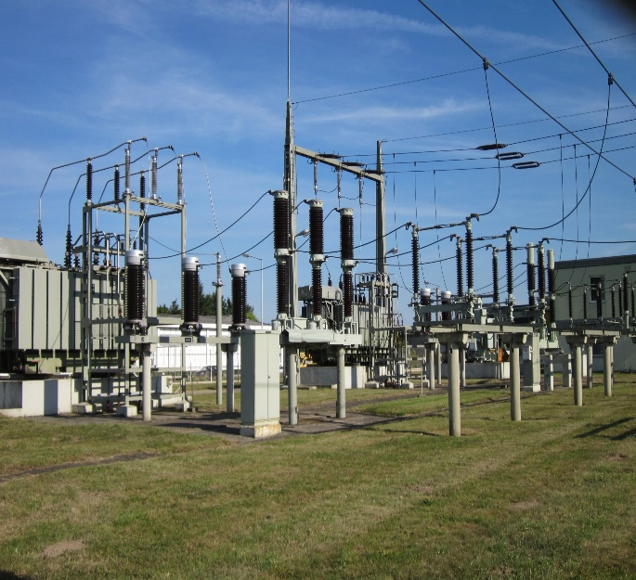
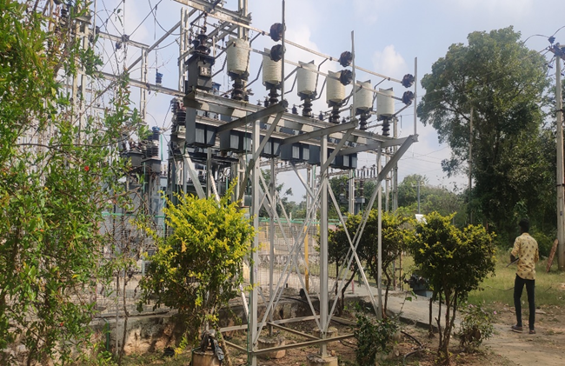

Types of Substation:
1.Transmission substation 4. Railways
2.Distribution substation 5. Mobile substation
3.Collector substation 6. Converter substation
1.Transmission Substation:
A transmission substation connects two or more transmission lines. The simplest case is where all transmission lines have the same voltage. In such cases, substation contains high-voltage switches that allow lines to be connected or isolated for fault clearance or maintenance. A transmission station may have transformers to convert between two transmission voltages, voltage control/power factor correction devices such as capacitors, reactors or static VAR compensators and equipment such as phase shifting transformers to control power flow between two adjacent power systems. Transmission substations can range from simple to complex. A small "switching station" may be little more than a bus plus some circuit breakers. The largest transmission substations can cover a large area with multiple voltage levels, many circuit breakers, and a large amount of protection and control equipment. Modern substations may be implemented using international standards such as IEC Standard 61850.
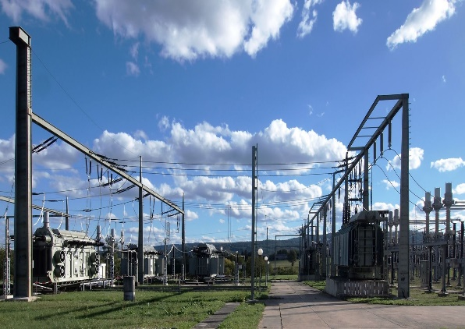
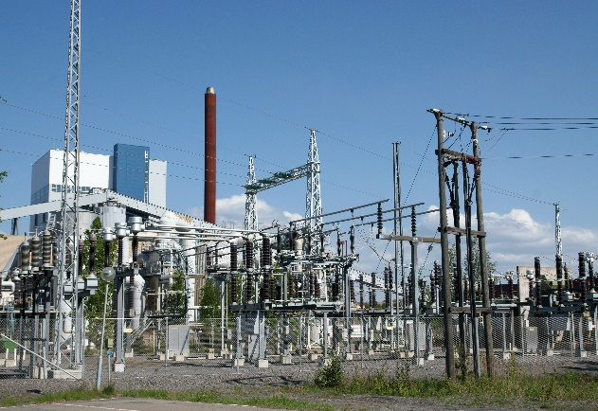
2.Distribution substation:
A distribution substation transfers power from the transmission system to the distribution system of an area. It is uneconomical to directly connect electricity consumers to the main transmission network, unless they use large amounts of power, so the distribution station reduces voltage to a level suitable for local distribution. The input for a distribution substation is typically at least two transmission or sub-transmission lines. Input voltage may be, for example, 115 kV, or whatever is common in the area. The output is a number of feeders. Distribution voltages are typically medium voltage, between 2.4 kV and 33 kV, depending on the size of the area served and the practices of the local utility.
3.Collector substation:
In distributed generation projects such as a wind farm or photovoltaic power station, a collector substation may be required. It resembles a distribution substation although power flow is in the opposite direction, from many wind turbines or inverters up into the transmission grid. Usually for economy of construction the collector system operates around 35 kV, although some collector systems are 12 kV, and the collector substation steps up voltage to a transmission voltage for the grid. The collector substation can also provide power factor correction if it is needed, metering, and control of the wind farm. In some special cases a collector substation can also contain an HVDC converter station. Collector substations also exist where multiple thermal or hydroelectric power plants of comparable output power are in proximity. Examples for such substations are Brauweiler in Germany and Hradec in the Czech Republic, where power is collected from nearby lignite-fired power plants. If no transformers are required for increasing the voltage to transmission level, the substation is a switching station.
4.Converter substations:
Converter substations may be associated with HVDC converter plants, traction current, or interconnected non-synchronous networks. These stations contain power electronic devices to change the frequency of current, or else convert from alternating to direct current or the reverse. Formerly rotary converters changed frequency to interconnect two systems; nowadays such substations are rare.
5.Switching station:
A switching station is a substation without transformers and operating only at a single voltage level. Switching stations are sometimes used as collector and distribution stations. Sometimes they are used for switching the current to back-up lines or for parallelizing circuits in case of failure. An example is the switching stations for the HVDC Inga–Shaba transmission line.A switching station may also be known as a switchyard, and these are commonly located directly adjacent to or nearby a power station. In this case the generators from the power station supply their power into the yard onto the generator bus on one side of the yard, and the transmission lines take their power from a Feeder Bus on the other side of the yard.
6.Railways:
Electrified railways also use substations, often distribution substations. In some cases a conversion of the current type takes place, commonly with rectifiers for direct current (DC) trains, or rotary converters for trains using alternating current (AC) at frequencies other than that of the public grid. Sometimes they are also transmission substations or collector substations if the railway network also operates its own grid and generators to supply the other stations.
7.Mobile substation:
A mobile substation is a substation on wheels, containing a transformer, breakers and buswork mounted on a self-contained semi-trailer, meant to be pulled by a truck. They are designed to be compact for travel on public roads, and are used for temporary backup in times of natural disaster.
Elements of a substation:
There are many elements are in every electrical substation they are:
1.Primary power lines' side
2.Secondary power lines' side
3.Ground wire
4.Overhead lines
5.Transformer for measurement of electric voltage
6.Disconnect switch
7.Circuit breaker
8.Current transformer
9.Lightning arrester
10.Main transformer
11.Control building
12.Security fence

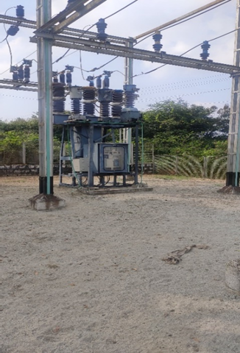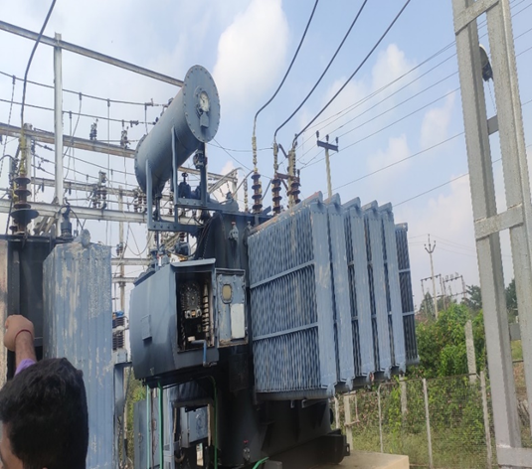

33/11 KV Substation:
The main bus 33KV is connected to grid located at Pathikonda , Chittoor . Now the transmission line first parallel connected with lighting arrester to diverge surge, followed by CVT connected parallel.
CVT measures voltages and steeps down at 110V. A.C. for control panel at the location a wave trap is connected to carrier communication at higher frequencies. A current transformer is connected in series with line which measure current and step-down current at ratio 800.1 for control panel. At both ends of transformer lightning arrester current transformer and switchgear equipment provided. In this 33/11KV electrical substation many elements or many transformer sections are there. We are observing many instruments and equipment in this electrical substation. Then we see in detail about their elements.
Transformers:
To step down the 33KV primary voltage to 11kv suitable for distribution purpose. One 33kv/0.415 auxiliary transformer was also needed to supply the substation with reliable AC power.
Circuit breakers:
Circuit breakers (CBs) were needed so as to disconnect and isolate the faulted section. Sulphur-hexa-fluoride (SF6) circuit breakers were chosen.
Isolating switches (isolators):
It is a requirement that whenever maintenance or repair work is to be carried out on equipment in a substation or feeders, it be disconnected from the supply by an isolator, normally operated on no load. Isolators are normally interlocked with circuit breakers and earthing switches.
Current and potential transformers:
Current and voltage transformers were needed so as step down the line current for the purpose of metering and relaying.
Busbars:
The incoming and outgoing circuits were connected to busbars. Flexible ACSR stranded conductor busbars supported from two ends by strain insulators was chosen for the 33kv busbar.
Protective relays:
Whenever a fault occurs the protective relay would operate and send a trip signal to circuit breakers. The relays were housed in panels in the control room and ring main units.
Surge arrestors (lightning arrestors):
Surge arrestors would protect the substation equipment from lightning and switching surges.
Earthing switch:
The earthing switch is usually connected between the line conductor and is mounted on the frame of isolator. Normally it is in open position. When the line is disconnected the earthing switch is closed to discharge the trapped charges to earth.
Three phase electric power:
Three-phase electric power is a common type of alternating current used in electricity generation, transmission, and distribution. It is a type of polyphase system employing three wires (or four including an optional neutral return wire) and is the most common method used by electrical grids worldwide to transfer power.
Three-phase electrical power was developed in the 1880s by multiple people. Three-phase power works by the voltage and currents being 120 degrees out of phase on the three wires. As an AC system it allows the voltages to be easily stepped-up using transformers to high voltage for transmission, and back down for distribution, giving high efficiency.
A three-wire three-phase circuit is usually more economical than an equivalent two-wire single-phase circuit at the same line to ground voltage because it uses less conductor material to transmit a given amount of electrical power. Three -phase power is mainly used directly to power large motors and other heavy loads. Small loads often use only a two-wire single-phase circuit, which may be derived from a three-phase system.
The Three phase current is mainly useful in industries and agricultural works like motors and many other things. So that in every electrical substation most of the current can transfer to industries.

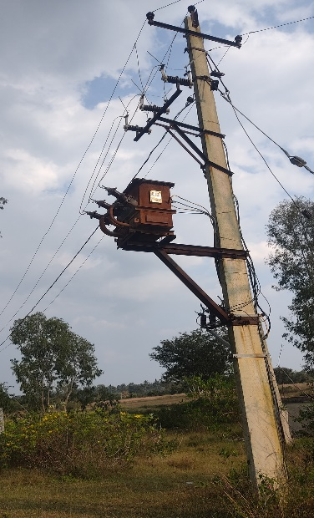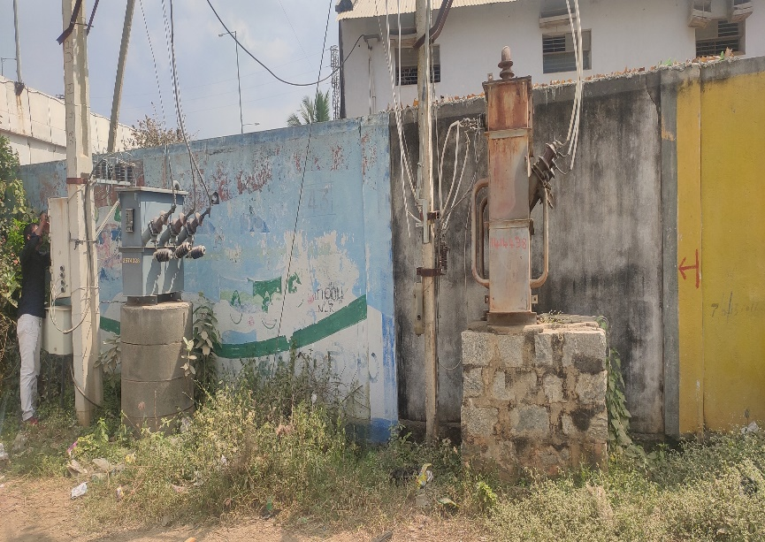
Single phase electric power:
Single-phase electric power is the distribution of alternating current electric power using a system in which all the voltages of the supply vary in unison. Single-phase distribution is used when loads are mostly lighting and heating, with few large electric motors. A single-phase supply connected to an alternating current electric motor does not produce a rotating magnetic field; single-phase motors need additional circuits for starting (capacitor start motor), and such motors are uncommon above 10 kW in rating.
Because the voltage of a Single -phase system reaches a peak value twice in each cycle, the instantaneous power is not constant. Standard frequencies of single-phase power systems are either 50 or 60 Hz. Special single-phase traction power networks may operate at 16.67 Hz or other frequencies to power electric railways.
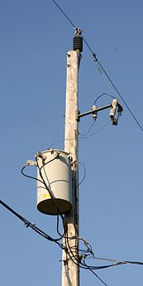
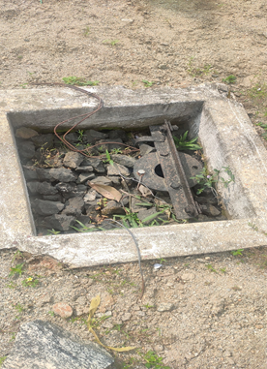
Advantages of Electric substation:
Outdoor Electrical Substation is located in Outdoor that’s means there will be no rooftop. The following advantage can be found by an outdoor substation.
1.The main construction work will be needed is much smaller if we compared it with an indoor substation.
2.Always less quantity of buildings or infrastructure is needed.
3.Insulation cost for switchgear and other electrical equipment is very low.
4.Adequate space between two separate adjoining equipment can be provided which can reduce the possibility of any kind of fault.
5.Erection and Commissioning for the substation can be completed in a much leaser time period.
6.All equipment can be viewed and it can help to find the fault location easier.
7.Future extension of the scheme is easier and whenever needed.
Disadvantages of electrical substation:
1.Always more space needed to arrange all the equipment.
2.The dirt and dust always deposit over the contact switch and other equipment, thus the maintenance cost can be increased.
In a conventional outdoor electrical substation (Rated 33KV and above) will have various substation equipment like Circuit Breaker, Current Transformer (C.T), Potential Transformer (P.T), Isolators, Earth Break Switch (A.B.S), Air Circuit Breaker (A.C.B) and some others will be installed under the open sky.
Necessary clearance needs to provide between phases and ground. The equipment for outdoor switchgear manufactured separately and it will be erected at the site as per the switchyard layout.
Observations:
In this 33/11kv electrical substation I see many transformers and its parts and also can understand how to operate and how to work its parts. In this substation two members are working they are work at in this place. This place is very peaceful and some small noises are also we will be hearing. Around in this substation have one small operating room also there. In that room some electronic machines and some electronic devises are there. They say some information about those properties after we understand very much. In this station every transformer has two or more earths are there.
This substation power is transfer in too many villages and some indus-tries.33/11kv substation observes the power from 132kv substation at Palamaner. The substation can divide in to several parts that means earthing system and express transformer and battery system. In this substation I observe many things as following:
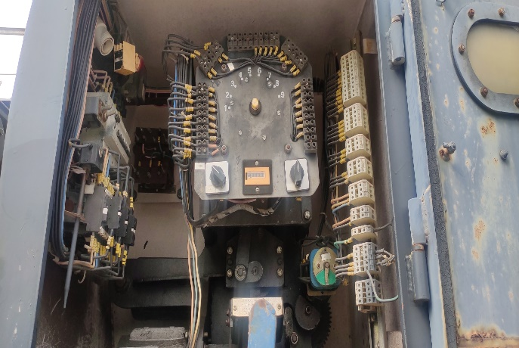
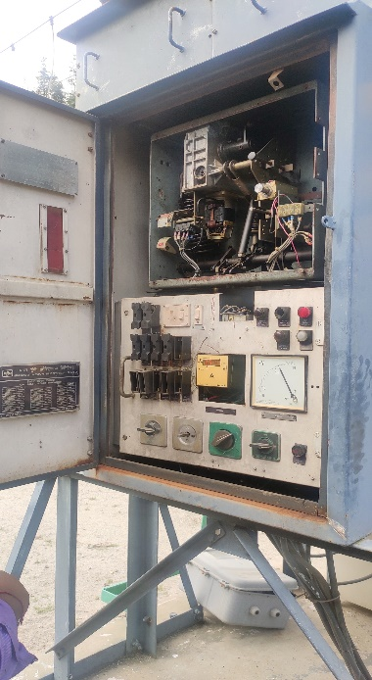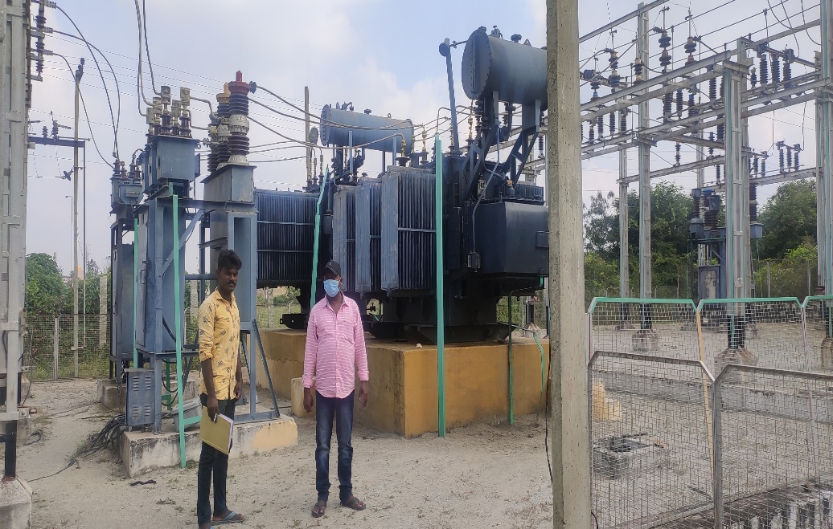

CONCLUSION

It was a wonderful learning experience for me while doing on this project. And more and more knowledge got about substation and its parts. I enjoyed each and every bit, each and every time in doing and visiting this place. I got more experience and more knowledge about how to work electric substation. And one more thing, this place is very dangerous to humans due every part will connect to electric power so that if we touch any substation material or element, we exposure to current shock. So that every one knowing about electric substation. Finally, I would like to share one thing ………save power.,.,.,.,.,.,.,

B.BABU.

